Copy and Paste Assignment
Directions: Use the copy (ctrl + c) and paste (ctrl + v) shortcuts to place each statement into either the YES or NO space.
YES | Statements | NO
I like to listen to music.
I like to watch scary movies.
I want to go to college.
I play a sport at school.
I am in a club.
I am confident in HTML coding.
I enjoy eating tacos.
I enjoy eating eggrolls.
I spend less than one hour on my phone a day.
I have a sweet tooth.
I have a very specific goal for 2018.
I usually or always do homework that teachers assign to me.
I am planning to get good grades this school year.
I think that the dress code is too strict at this school.
Directions: Use the cut (ctrl + x) and paste (ctrl + v) shortcuts to put the lines of the song into order in the blank space.
Out of Order Song | Put the Song In Order Below
Went up the spout again
And dried up all the rain
The itsy bitsy spider
Washed the spider out
Now the itsy bitsy spider
Down came the rain and
Went up the water spout
Out came the sun
Out of Order Song | Put the Song In Order Below
All the king’s horses
Couldn’t put Humpty
Humpty Dumpty sat
Had a great fall
Humpty Dumpty
On a wall
And all the king’s men
Together again.

Star Spangled Banner
O! say can you see by the dawn's early light, What so proudly we hailed at the twilight's last gleaming,

Whose broad stripes and bright stars through the perilous fight, O'er the ramparts we watched, were so gallantly streaming? And the rockets' red glare, the bombs bursting in air, Gave proof through the night that our flag was still there; O! say does that star-spangled banner yet wave O'er the land of the free and the home of the brave?
Turn This:

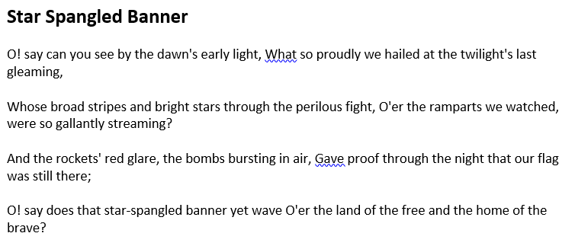
into This:

Type This:
In This Box:

